Chevron Delo 600 ADF Oils Approved for Cummins Mobile Natural Gas Engines. The only ultra-low ash engine oil approved for use in mixed CNG and diesel engine fleets.
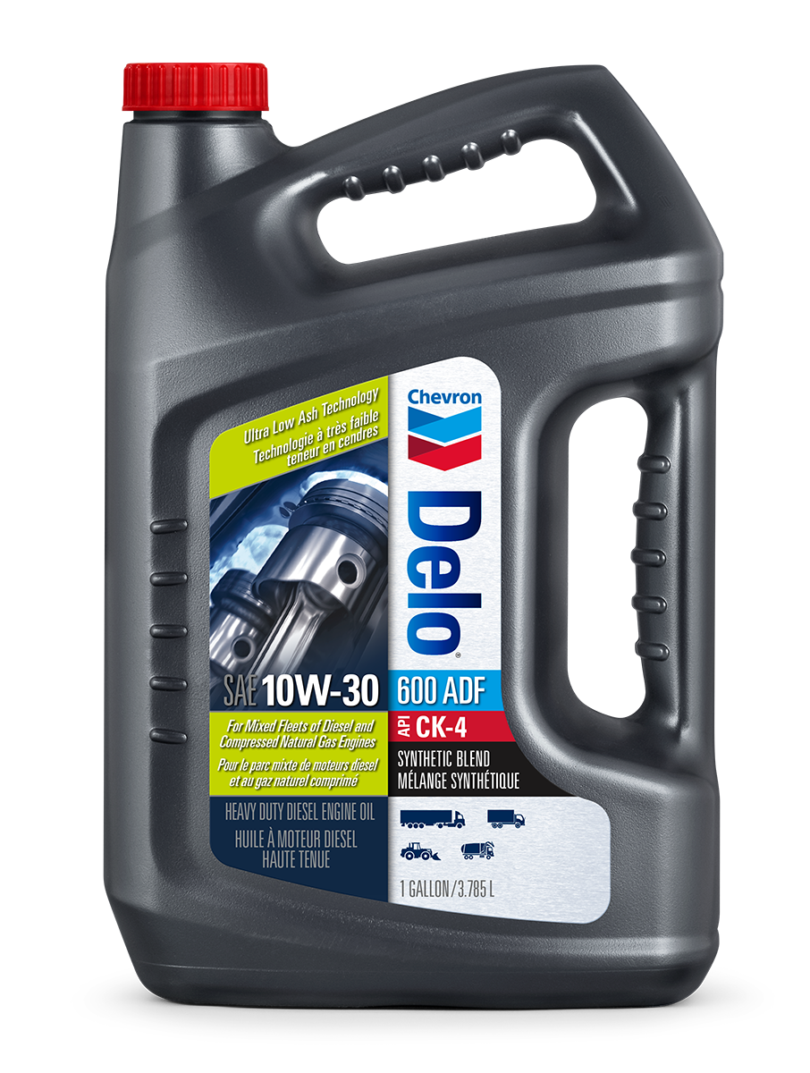
May 15, 2023—San Ramon, Calif. – Today, Chevron Products Company, a subsidiary of Chevron, U.S.A. announced Delo® 600 ADF 10W-30 and Delo® 600 ADF 15W-40 heavy-duty engine oils are approved for use in Cummins mobile natural gas engines. The Cummins’ approval process requires two years of field testing in Cummins engines sold to the on-highway market, followed by a tear-down of the engines and review by Cummins. After putting Delo 600 ADF through this rigorous process, it has now received approval for use in Cummins natural gas engines and is registered to CES 20092.
Delo® 600 ADF 10W-30 and Delo® 600 ADF 15W-40 were introduced in 2019, offering the first diesel engine oils formulated with OMNIMAXTM, a patented ultra-low ash (ULA) technology designed to solve the problem of ash build-up from engine oil additive packages in diesel particulate filters (DPFs). Delo® 600 ADF products have been proven to help improve fuel economy retention, forced regenerations, and lessen the downtime required to properly service and remove ash from the units.

“Shortly after launching Delo® 600 ADF, we saw that these products naturally align with Cummins CES 20092 specification for mobile natural gas engine oils,” said Shawn Whitacre, Chevron senior staff engineer. “As the leading manufacturer of natural gas engines in North America, Cummins sets the industry standard for mobile natural gas engine oils. We’re excited that we can now offer fleet operators a single oil for both diesel and natural gas-powered vehicles.”

“Having a single oil for both diesel and natural gas-powered vehicles should make life much easier for fleet operators,” said Whitacre. “With the upcoming launch of a CNG powered 15L engine, we are already hearing from long haul operators looking for a one-oil solution for their mixed fleet. Delo® 600 ADF delivers all the performance benefits of an API CK-4 heavy duty diesel oil, combined with the ultra-low ash technology that helps protect diesel after-treatment systems while reducing fuel consumption, and now meets the very exacting standards of a natural gas engine oil as well.”
For more information on Chevron Delo 600 ADF, go to Chevron Delo® 600 ADF 10W-30 Low Ash Diesel Engine Oil | Chevron Lubricants (US) and Chevron Delo 600 ADF 15W-40 Low Ash Diesel Engine Oil | Chevron Lubricants (US)

About Chevron Products Company

Chevron Products Company is a division of an indirect, wholly owned subsidiary of Chevron Corporation (NYSE: CVX) headquartered in San Ramon, CA. A full line of lubrication and coolant products are marketed through this organization. Select brands include Havoline®, Delo® and Havoline Xpress Lube®. Chevron Intellectual Property LLC owns patented technology in advanced lubricants products, new generation base oil technology and coolants.

MEDIA CONTACT:
Bobbi Hochberg, BCW on behalf of Chevron Lubricants
bobbi.hochberg@bcw-global.com

About Chevron
Chevron is one of the world’s leading integrated energy companies. We believe affordable, reliable, and ever-cleaner energy is essential to enabling human progress. Chevron produces crude oil and natural gas; manufactures transportation fuels, lubricants, petrochemicals and additives; and develops technologies that enhance our business and the industry. We aim to grow our traditional oil and gas business, lower the carbon intensity of our operations, and grow new lower carbon businesses in renewable fuels, hydrogen, carbon capture, offsets and other emerging technologies. More information about Chevron is available at www.chevron.com

###

